

**Help Your Child Grow into Their Future Careers & the World of Work**

**Emma Smith – Careers Leader. Doncaster School for the Deaf https://www.deaf-trust.co.uk/school**

**How can I best support my child toward their career dreams?**

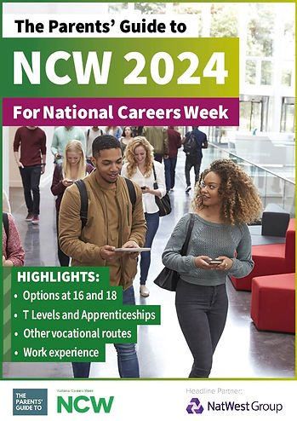

parent guide

**CLICK HERE -FREE!**

[National Careers Week - parent/teacher guide (theparentsguideto.co.uk)](https://www.theparentsguideto.co.uk/nationalcareersweek)

A great website for **you** and **your child**.

**Sign up to their FREE 'Parents Guide' newsletter.**

Making supportive choices.

**\*Remember\*** there are no such things as *boy* jobs or *girl* jobs – **equality matters**, follow your interests, wants and dreams

**How can I support my child toward their career when they leave school – go to college, work, their future?**

1. **Accept their ideas may be different to yours.**

Your child’s dreams & ambitions might not be what you wanted. This can be disappointing but let them walk their own path.

**2.** **It’s OK if they’re not sure on a career route yet**

Your child doesn’t need to make a decision right now. They need to develop skills to help them progress, and that should be their focus.

**3. Encourage them**

Your child is more likely to be successful (and happier) doing a career in something they enjoy

**4. Help them find their way**

Not being academic should not be a barrier to success, there are lots of ways to achieve your career.

**5. It’s OK if they change their mind!**

Talk with your child that it’s ok to change their minds, you won’t get cross about it.

**6. Encourage them to research their options**

Help them plan out a way that focuses on their strengths. There are lots of different educational routes to the job/career they want

**7. Help them if they are struggling to look far ahead**

Setting short-term goals will help them move forward to their long-term dreams.

**8. Empower them: they have control over their future**

Encourage your child’s decisions & what they do matters

**There are 8 Gatsby benchmarks below. We aim to cover:**

1. Provide a stable careers programme. (This can be seen on our website it tells you how we guide our pupils for their future)

1. Teach our pupils how to learn from career and labour market information (which jobs are needed where they live)

3. Address the needs of each pupil

4. Link curriculum learning to careers

5. Provide visits & talks with employers and employees.

6. Provide experiences of workplaces

7. Provide visits with further education settings (colleges, Universities etc)

8. Give personal guidance

Click Here for more information

[Good Career Guidance | Education | Gatsby](https://www.gatsby.org.uk/education/focus-areas/good-career-guidance)

**Emma Smith – Careers Leader. Doncaster School for the Deaf https://www.deaf-trust.co.uk/school**