Doncaster School for The Deaf
Parent Information

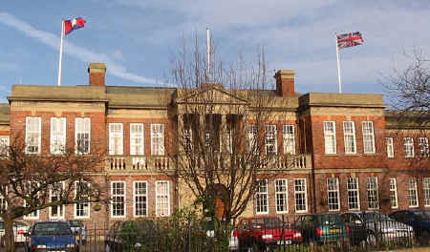

Doncaster School for The Deaf
Leger Way
Doncaster
DN2 6AY
Telephone: 01302 386733
Email: secretary@ddt-deaf.org.uk

Follow us on:
Facebook: https://www.facebook.com/DoncasterSchoolfortheDeaf/
DfE no: 3717002
Registered Charity Number:1088060

Vision:
To be a national leader of Deaf education and care, achieving outstanding outcomes that improves children’s lives.
Mission:
To provide outstanding specialist education and care, for Deaf children. To continue to develop partnerships and promote collaboration for the benefit of our children and the wider community. We ensure our children progress to achieve success in order to promote independence and employability.

School Team
Leadership Team
Alexis Johnson – Executive Principal
Jane Goodman – Deputy Headteacher
Teresa Cartlidge – Assistant Headteacher
Lana Cook – Pastoral Lead (Designated Safeguarding Lead)
Kate Warner – Children’s Home Manager (Deputy Designated Safeguarding Lead)

Teaching Staff
Stephanie Fogg – English
Sam Bunting – Science
Richard Brennan – Maths
Helen Dargan – Humanities
Michael Hirst – CSICT
Rebecah Taylor – P.E., British Sign Language & Humanities
Shauna Flannigan – Creative Arts & British Sign Language
Susan Carline – Art
Lyndsey Gaywood – Personal, Social, Health & Economic (PSHE) & P.E.
Rachel Lyon – Primary
Lauren Croggon – Primary
Anna Blakey – Primary
Laura Robinson Felkin – Primary
Rachael Peace – Primary

Specialist Teaching Assistants
Administration Team
Louise Wilkinson
Diane Fiedor

Jo Alawoya
Kim Priestly
Lisa Drury
Olivia Allen
Trina Graby
Amy Ball

Sam Laverack
Emma Smith
Tracy Brown
Rachel Bruce
Leanne Round
Sarah McGeechan
Susan Dewey

Therapist Team
Emma Robinson – Speech & Language Therapist
Lauren Woodcock – Speech & Language Therapist
Emma Taylor – Speech & Language Therapist
Amanda Simmonite – Occupational Therapist
Jim McHugh – Audiologist

Location and facilities

Doncaster School for the Deaf is located opposite Doncaster Racecourse. We have easy access to nearby motorways.

Your text here

The school has bright, modern classrooms with interactive whiteboards, offering a pleasant learning environment
Our fully equipped specialist rooms include:
- Science laboratory
- Design and Technology workshop
- ICT suites
- Food technology classroom
- Sports Hall
Onsite sports facilities include:
- Sports centre
- Playing fields covering 6 acres
- Tennis courts
- Football pitch
- Hard core for tennis, football, netball etc.

Term Dates and Training Days
DONCASTER SCHOOL FOR THE DEAF
SCHOOL HOLIDAYS 2020-2021
Holiday | School closes  (for Pupils) | School opens  (for Pupils) | Teaching Days
 |  | Thursday 3rd September 2020 | 36
Autumn Half Term | Thursday 22nd October 2020 | Monday 2nd November 2020 | 35
Christmas Holiday | Friday 18th December 2020 | Monday 4th January 2021 | 29
Spring Half Term | Thursday 11th February 2021 | Monday 22nd February 2021 | 25
Easter Holiday | Friday 26th March 2021 | Tuesday 13th April 2021 | 14
May Day Bank Holiday | Friday 30th April  2021 | Tuesday 4th May 2021 | 19
Summer Half Term | Friday 28th May 2021 | Monday 7th June 2021 | 32
Summer Holidays | Tuesday 20th July 2021 |  | Total  190
Teacher Training Days (School closed for pupils)
Tuesday 1st & Wednesday 2nd September 2020
Friday 23rd October 2020
Friday 12th February 2021
Monday 12th April 2021

Parental Right to Information

Parents/carers may visit school and view, or have copies of, any policy statements and schemes of work, by prior arrangement. Many policies are available on our website to download. School receives many documents and regulations, which may be viewed by parents upon request.

Communication with parents & carers

At Doncaster school for the Deaf we communicate with parents and carers in various ways, for example through our newsletters, questionnaires, Facebook, text, Zoom, Teams, email, formal and informal events. Parents and carers are invited to assemblies and to Parents’ and Carers’ Evenings. Every year parents, carers and others are invited to attend our Prize Day and Sports Days as well as children’s performances. Staff are always be happy to meet with parents and carers to discuss progress and any concerns. Our website has a wealth of information including our newsletters, and copies of key policies.

For further enquiries for any of the following please:
Email: secretary@ddt-deaf.org.uk
Phone: 01302 386733

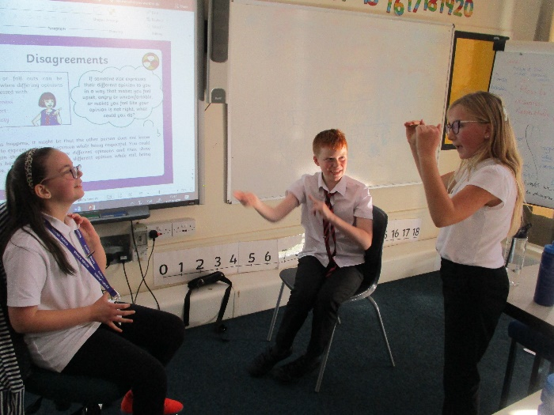
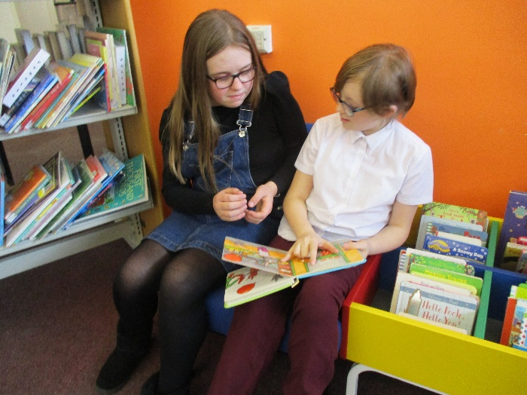
Admissions
For full details see Admissions Policy on the school website

Admission arrangements
Placements can be made at any time during the school year
Parents or Carers considering the school are invited to contact the school office to arrange a visit.
Prospective pupils are invited for assessment visits. There is no fixed system for this. It may be appropriate for shorter visits and observations in a pupil’s current placement or at home/school. Once a placement is agreed transition visits can be arranged.
Doncaster School for the Deaf is a non-maintained special school. Applications are usually made through Local Authorities. We welcome visits from parents/carers and will support parents in their applications to local authorities with consideration of the SEN Code of Practice 2015.
- The school is a provision for 5 – 19-year-old children and young people
- The school is a provision for pupils who are Deaf/ Hearing Impaired. We may also accept pupils who are not Deaf if our provision will enable them to progress.
- Pupils usually have an EHCP in place on admission or the school supports the Local authority in assessment for their EHCP.
- A Home-School agreement is in place, but any admission, or refusal of, may not be conditional on parents signing the agreement
- All requests for a placement should be responded to within a reasonable period subject to the information available

Attendance
For full details see the Attendance Policy on the school website

Our school aims to meet its obligations with regards to school attendance by:
- Promoting good attendance and reducing absence, including persistent absence
- Ensuring every pupil has access to full-time education to which they are entitled
- Acting early to address patterns of absence
Research shows that regular attendance at school coupled with prompt arrival has a significant effect on children’s educational attainment.
DSD believes in partnership between school and parents/carers and is committed to work with parents/carers to improve punctuality and attendance. We firmly believe that all pupils benefit from regular school attendance. To this end we will do all we can to ensure that any problems that prevent full attendance are identified and acted on promptly.

Parents' Responsibilities
Parents have a legal duty to ensure that children attend school regularly
Parents should ensure that if their child is to be absent from school for any unavoidable reason such as sickness they should contact the school as soon as possible, by 9:00 am, preferably on the first morning of absence. This may be done by phone, by letter/ note, or in person.
Parents should inform the school in advance of any medical or other appointments.
Parents should inform Local Authority Transport Department if any alterations to normal travel arrangements are made.

Timing of the School Day
Days | Arrival/Registration | Lesson 1 | Departure
Monday | 9.15 | 9.30 | 3.15
Tuesday – Thursday | 8.45 | 8.50 | 3.15
Friday | 8.45 | 8.50 | 2.30

School Closure
In the event of a decision to close the school e.g. in the case of severe weather, parents and staff will be informed via our text service. A headline message will also be posted on the School website and on social media.

Complaints
For full details see the Complaints Procedure Policy on the school website

Doncaster School for the Deaf (DSD) aims to resolve all complaints at the earliest possible stage and is dedicated to continuing to provide the highest quality of education possible throughout the procedure.
Any person, including a member of the public, is able to make a complaint about the provision of facilities or services that the school provides. The policy outlines the procedure that the complainant and school must follow.
Once a complaint has been made, it can be resolved or withdrawn at any stage.
The headteacher will be the first point of contact when following the complaints procedure.

Safeguarding
The schools safeguarding Policy is available on the website

The Designated Safeguarding Lead is Lana Cook
The Deputy Safeguarding Lead is Kate Warner
Tel 01302 386733
Email : scook@ddt-deaf.org.uk
The Safeguarding Governor is Susan Dumican
We believe that all members of the School and wider community are entitled to be treated with respect and dignity at all times.
It is important that every child feels cared for and they know whom they can turn to if they have a problem.
Safeguarding Children
The School is inclusive and committed to the care and well-being of its pupils so that they may grow and learn in a safe, secure environment. Our safeguarding policy guides our staff, pupils, parents and professionals who work together, taking positive action to safeguard children and promote their welfare. Our School follows best practice with regard to the safer recruitment of staff.
Health, Safety and Security
The School and Trust have a rigorous Health and Safety Policy which reflects current legislation and seeks to ensure safety for all. External CCTV, digital security access and security staff are measures taken to ensure a secure and safe environment for everyone on site.

Anti- Bullying
For full details see the Anti-Bullying Policy on the school website
Doncaster School for the Deaf (DSD) believes that all pupils are entitled to learn in a safe and supportive environment; this means being free from all forms of bullying behaviour.
Learning about tolerance and difference as part of the school’s curriculum, aim to promote an inclusive, tolerant and supportive ethos at the school.
All staff, parents and pupils work together to prevent and reduce any instances of bullying at the school. There is a zero-tolerance policy for bullying at the school.

SUPPORT ORGANISATIONS:

- Advisory Centre for Education (ACE) 0808 800 5793

- Children's Legal Centre 0845 345 4345

- KIDSCAPE Parents Helpline (Mon-Fri, 10-4) 0845 1 205 204

- Parentline Plus 0808 800 2222

- Youth Access 020 8772 9900

- Bullying Online, charity providing an email service as well as lots of online help and advice and information for pupils and schools www.bullying.co.uk

- Visit the Kidscape website www.kidscape.org.uk for further support, links and advice

- Anti-bullying Alliance (ABA) was founded by the NSPCC AND National Children’s Bureau in 2002; it brings together over 65 organisations into one network. aba@ncb.org.uk

- Childline – 24 hour telephone helpline for children, website has advice and help www.childline.org.uk

- Wired Safety – lots of online help and advice in particular regarding cyber safety www.wiredsafety.org.uk

You can contact the school for further guidance or information about supporting organisations

Anxieties and Worries
Please contact the school if your child has any anxieties or worries.
Behaviour
For full details see the Positive Behaviour Policy on the school website

The Communicative Function of Behaviour;
Behaviour management and the promotion of positive behaviour do not constitute a discrete, separate element of life at Doncaster School for the Deaf. We believe that all presenting behaviours, whether belonging to pupils or staff, are communications and as such efforts should be made to understand and respond appropriately to them. We embrace the view that most, if not all, behaviour is fundamentally good in intention – designed to safeguard the physical and/or emotional survival needs of the individual/s concerned. Poor behaviour therefore represents the expression of legitimate needs, albeit inappropriately expressed.
All school staff are encouraged and supported to better understand pupil communications and the relationship between responses given and the behaviours they elicit.
PHILOSOPHY
Doncaster School for the Deaf (DSD) aims to create a calm, positive and safe learning environment, which encourages good social behaviour and respect for self and others. DSD recognises that pupils learn most effectively and behave appropriately when they know what is expected of them, when they are positively encouraged to behave well, have ample opportunity for success and when they are consistently and fairly treated at all times.
Pupils should see that consequences are fairly and consistently applied and are directed towards the behaviour rather than towards them as individuals.
“Disapprove of the behaviour – not the child”
A clear, agreed and known code of conduct ensures that everyone is aware of what is acceptable behaviour. This will take the form of a limited number of school rules established through discussion between staff and pupils.
We believe in the right of all school community members:
- To feel physically and emotionally safe;
- To learn and develop to the best of their ability;
- To be respected and valued as an individual;
- To a learning environment, where tolerance, fairness and courtesy prevail;
- To express their views, be listened to and consulted;
- To clear and consistently applied expectations and boundaries;
- To learn from our mistakes through opportunities to discuss them;
- To accept responsibility for their own behaviour and make amends.

Pastoral Care in School

Each morning pupils have a form group period. At this time hearing aids and equipment are checked, homework reviewed and activities such as reading /spellings completed.
Pupils have form / class teachers who we encourage pupils to talk to or a staff member they trust, about any problems that they may have. We will do everything in our power to overcome any issues, whether large or small.

We are also extremely fortunate to have a caring and experienced pastoral lead, Lana Cook. Problems do arise sometimes, either at home or at school, which may well affect the progress, academic or social development of a pupil. We do ask that parents keep us informed of any problems and we will do likewise in return. Although parents are invited to meet the teacher most directly concerned with the child on formal occasions (such as parents’ evenings), we cannot stress strongly enough the importance of coming into school to discuss any matter.
We work closely with external agencies such as Deaf CAHMS who can provide support or advise us.

Equality
For full details see the Equality and Objectives Statement and Equality information and Objectives Policy on the school website

Doncaster School for the Deaf recognises that certain groups in society have historically been disadvantaged because of unlawful discrimination they have faced due to their race, sex, disability, gender reassignment, marriage/civil partnership, religion/belief, sexual orientation or age.
We aim to promote pupils’ spiritual, moral, social and cultural development, with special emphasis on promoting equality and diversity, and eradicating prejudicial incidents for pupils and staff. Our school is committed to not only eliminating discrimination, but also increasing understanding and appreciation for diversity.

We believe that a greater level of success from pupils and staff can be achieved by realising the uniqueness of individuals. Creating a prejudice-free environment where individuals feel confident and at ease is a commitment of the school. This environment will be achieved by:
- Being respectful.
- Always treating all members of the school community fairly.
- Developing an understanding of diversity and the benefits it can have.
- Adopting an inclusive attitude.
- Adopting an inclusive curriculum that is accessible to all.
- Encouraging compassion and open-mindedness.

We are committed to having a balanced and fair curriculum. We believe that our pupils should be exposed to ideas and concepts that may challenge their understanding, to help ensure that pupils learn to become more accepting and inclusive of others. Challenging and controversial concepts will be delivered in a way that prevents discrimination and promotes inclusive attitudes. We will also respect the right of parents to withdraw their children from certain classes which pose conflicts to their own beliefs.

Education Health and Care Plans (EHCP)

All pupils at Doncaster School for the Deaf have an EHCP. These must be reviewed annually. The school will invite
- The pupil
- The pupil’s parents/ carers
- A representative from the LA
- Interpreters as required
- Any other person the SENCo/or Headteacher consider appropriate.
- Any other person the LA consider appropriate
- Parents can request invitations for other people
Further information about EHCPs and the Annual review process can be found at
https://www.gov.uk/government/publications/send-code-of-practice-0-to-25

Transport
Transport to and from DSD is the responsibility of the sponsoring authority and parents/carers should liaise with their LA.

Curriculum
For full details see the Curriculum Plans on the school website

What are we trying to achieve?
These are the main intended features of our curriculum:
- Constantly reviewed
- Reflects the needs of individual learners
- Based on the National Curriculum with the exemption of a modern Foreign language
- Adaptions to reflect our Deaf learners, inclusion of BSL, Deaf Studies, smILE therapy
- Inclusion of enrichment opportunities
- Ambitious for every learner
- Adaptions for a wide ability range and range of learning styles.

Our aim is that our learners become independent, resilient, confident young people. School staff and leaders promote a strong sense of identity and set out to prepare our young people for further or higher education and/or the world of work.

We aim that pupils respect their own and others’ identity, views, rights, faiths and beliefs and the law and that they embrace diversity, and have the skills and values to help them contribute as a respected member of society.
Our Key Stage 4 offer includes GCSEs, Level 1 and Level 2 qualifications, Entry Level Certificate (ELC) qualifications and Unit Awards.
Access to Occupational Therapy (OT), Audiology and Speech and Language Therapy (SaLT) is available to all pupils.

How do we organise learning?
Teacher’s aim to ensure that building blocks needed for learning are in place and they recognise that to embed learning into long term memory there is an element of repetition required. Any misconceptions and gaps need to be addressed so plans may need to be adapted throughout the year.
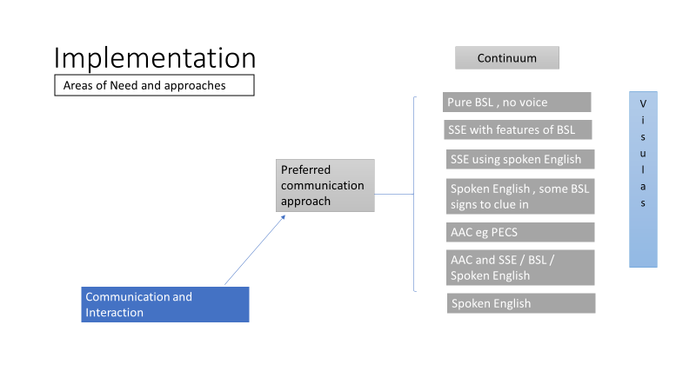
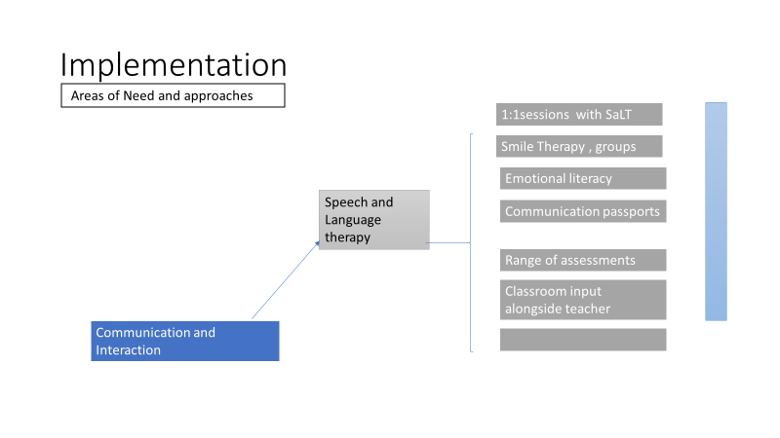
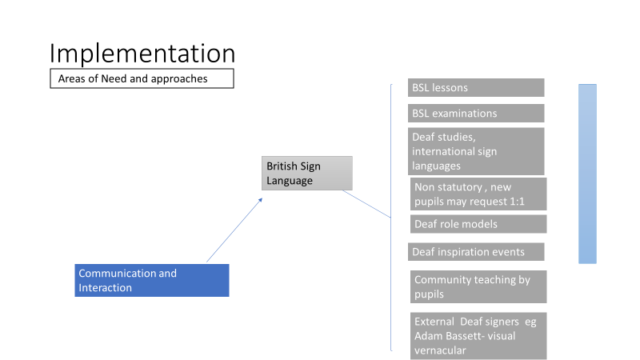

Further information on the above, areas of need and curriculum can be found on our website

Careers Education Guidance and Economic Wellbeing
Our Careers leaders are:
Ms J Goodman (jgoodman@ddt-deaf.org.uk) Tel :01302 386733
and Mr S Bunting (sbunting@ddt-deaf.org.uk)
Our Careers adviser is Ms S Beaumont (Level 6 Diploma in Careers Guidance and Development, Level 6 in Careers Leadership)
The main aims of careers provision at Doncaster school for the Deaf are to:
- Prepare pupils for life post-education.
- Develop an understanding of different career paths and challenge stereotypes.
- Develop an understanding of the differences between school and work.
- Inspire pupils to chase and achieve their dreams.
- Help pupils to access information on the full range of post-16 education and training opportunities.
- Support pupils after leaving school.
- Offer targeted support for all young people.
- Instil a healthy attitude towards work.
Doncaster School for The Deaf is part of the Sheffield City Region Careers hub and works closely with schools and leaders within the Careers hub to promote careers and embed the Gatsby Benchmarks.
Teaching staff create a learning environment that allows and encourages pupils to tackle real life challenges, manage risks and develop skills that can be applied to the workplace
Our careers programme includes:
- providing pupils with on-going independent careers guidance. Planning will be centred around the pupil and explore their aspirations around what they want to be able to do when they leave school in terms of education or training including what support they will need to achieve his ambition.
- Supporting pupils to research options for Post 16 learning etc and the range of settings where they can potentially further their study. The school will endeavour to include supported visits to such settings so they can experience taster days or open days.
- providing opportunities to meet alumni, employers, employees and experience workplaces
- providing opportunities to learn from enterprise and careers events

Learning Beyond School and Enrichment
To enhance their learning, children and young people are given the opportunity to take part in day visits to such places as art galleries, exhibitions, museums and theatres as well as other locations such as work place environments.
To develop the whole person, we offer a range of activities for the pupils that take place on a Friday afternoon. Opportunities to get involved in art, dance and drama activities feature regularly. Pupils are also involved in a range of Enterprise challenges and interviewing external visitors.
All pupils are given opportunity and encouraged to attend residential outdoor activity centres. Residential activities include Low Mill Activity Centre for secondary pupils and Kingswood Activity Centre for primary pupils
Speech and Language Therapy
In Speech and Language Therapy we believe that every pupil has a right to develop their communication skills to the best of their ability, using the most appropriate methods for them (be it speech, sign language, picture exchange or a combination of these). We aim to prepare them to communicate effectively with both hearing and other Deaf people in society.
Pupils are encouraged to use their personal hearing aids and cochlear implants throughout the day to enable them to communicate more effectively.
All pupils have access to direct Speech and Language Therapy (SaLT), which is delivered on an individual basis or in small groups depending on the need of each pupil. Therapeutic input is also provided within the classroom, to ensure teaching and support staff are confident in using recommended strategies, and staff also receive training from the SaLT team.
Pupil’s needs are assessed through formal testing, observations and interactions with them, and liaison with relevant staff members and parents. The most appropriate means of supporting and developing their communication is then decided upon. Many factors are taken into account when setting individual therapy targets, including current communication levels, motivation and potential to improve, and any additional needs to be considered.
Occupational Therapy
The central role of Occupational therapy (OT) in school is to help children improve their fine and gross motor skills, and motor planning. OT works on skills that children need to do the things they struggle with, from zipping their coat to writing and typing.
Therapy is tailored to the child’s specific needs and treatment goals are formulated after an initial period of assessment. Treatment aims are reviewed regularly and the OT works very closely with teaching staff to monitor progress.
Sessions take place on a one to one or small group format. Wherever possible the OT will work with the child in class alongside teaching staff, in order to promote integrated learning of skills.
Audiology
We believe that every deaf pupil has the right to access and benefit from audiological services, equipment and services of the highest quality.
The School has a full-time onsite audiologist with access to the latest equipment, enabling pupils to be tested regularly and ensure they are fitted with the most beneficial hearing aid. Spare moulds are kept for all pupils so aids can be loaned to pupils if theirs need repairing. Many pupils have cochlear implants and so spare parts such as leads or magnets can be fitted if faults arise so pupils can have continued amplification.
The department strives to ensure every pupil has the necessary equipment and is able to maximise their residual hearing and learning experience.
Medical
The school has a well-equipped medical room. The school has a qualified NHS nurse on site throughout the day. When she is not available staff are trained in paediatric first aid and first aid at work. The nurse works with other services to provide services such as dental check-ups and immunizations.
Administration of Medicines in School
For full details please refer to the Administering Medications Policy and Supporting Children with Medical Needs Policy on our website

Doncaster School for the Deaf will ensure that pupils with medical conditions receive appropriate care and support at school, in order for them to have full access to education and remain healthy.
The school is committed to ensuring that parents/carers feel confident that we will provide effective support for their child’s medical condition, and make the pupil feel safe whilst at school.

Religious Education (RE)
RE is a compulsory part of the school curriculum in England and Wales. Pupils study Christianity and other world faiths and religions as well as investigating social and world issues. Please inform the school in writing if you wish your child to be wholly or partly excused from attending any Religious Education or Collective Worship at school. You do not need to explain your reasons for seeking withdrawal. Any child withdrawn from our religious education programme or acts of collective worship through parental request will be supervised as appropriate.

Relationships and Sex Education Programme (RSE)
The programme seeks to ensure that all children and young people accept their own and others' sexuality positively in order to enjoy relationships based on mutual respect, dignity and responsibility. The biological aspects are largely taught within the science curriculum whereas the emotional, legal and moral aspects are covered in the personal wellbeing programme supplemented by work done by other subjects such as religious education. Great care is taken to teach this work in a manner which promotes a responsible attitude towards sexual behaviour and the value of family life. Further information is available from the school. By law, parents have a right to withdraw their children from Relationship and Sex Education aspects of PSHE and it is the legal responsibility of the school to inform you of this right. Should you wish your child to be wholly or partly excused from attending any Relationship and Sex Education lessons can you please inform the school in writing. You do not need to explain your reasons for seeking withdrawal.
E Safety
For full details see the E Safety Policy on the school website

Protecting young people and adults properly means thinking beyond the school environment. Broadband, Wi-Fi and 3/4G connections now mean the world wide web is available anywhere, anytime. Moreover, the introduction of the internet on games consoles, tablets and mobile phones mean it is becoming increasingly difficult to safeguard our children from the dangers hidden in cyberspace.
Our children will not only be working online in school or at home; their personal devices are not always covered by network protection and it is, therefore, imperative that they are educated on the risks involved with using the internet and are provided with guidance and a range of strategies on how to act if they see, hear or read something that makes them feel uncomfortable.
We:
- Allow young people to develop their own protection strategies for when adult supervision and technological protection are not available.
- Give information on where to seek help and how to report incidents.
- Help young people understand that they are not accountable for the actions that others may force upon them but that there are sanctions that the school will impose if they act inappropriately when online.
- Provide guidelines for parents and others on safe practice.
- Ensure technological solutions are regularly reviewed and updated to ensure maintenance of an effective e-safety programme.

Charging and Remissions
For full details see the Charging and Remissions Policy on the school website

Doncaster School for the Deaf is committed to ensuring equal opportunities for all pupils, regardless of financial circumstances. No child is discriminated against by our offering of school trips, activities and educational extras.
We do not charge for educational visits provided during school hours.
School Meals
At Doncaster school for the Deaf (DSD) pupils are not charged for school meals. Fruit is provided at break and lunch. DSD is dedicated to providing an environment that promotes healthy eating and enables children and young people to make informed choices about the food they eat.
DSD has the Healthy Learning Healthy Lives Accreditation.
Our Nurse and Occupational Therapist, carry out and implement risk assessments for individual children with nutritional needs and eating disorders to ensure that all diets and allergies are catered for e.g. cultural, vegetarian, nut allergy, coeliac, diabetic, hyperactivity. In healthy eating, as in all other areas of the curriculum we recognise the value of the individual and strive to provide equal access of opportunity for all.
Personal Property

DSD does not regard itself as responsible for the personal property of pupils. Obviously, if an item is mislaid we will do everything in our power to find it, but we would ask you to discourage your child from bringing valuable items to school.

Mobile phones or electronic game devices (or equivalent) are not allowed in school. We recognise some of our pupils travel some distances to attend school and these can be a good distraction entertainment during the journey. On arrival mobile phones or electronic games are placed in lockers or given to staff to keep safe.

We do not encourage the wearing of jewellery (rings, necklaces etc) for school. Earrings should be small studs. A watch can be worn when not participating in PE lessons the class-teacher will arrange where any items are to be placed once removed, however school will not accept responsibility for their loss, or damage.

Data Protection
For further information please request a copy of the Records Management Policy and Trust Data Protection Policy

Doncaster School for the Deaf is committed to maintaining the confidentiality of its information and ensuring that all records within the school are only accessible to the appropriate individuals. In line with the requirements of the GDPR, the school also has a responsibility to ensure that all records are only kept for as long as is necessary to fulfil the purpose(s) for which they were intended.
Doncaster Deaf Trust aims to ensure that all personal data is collected, stored and processed in accordance with the General Data Protection Regulation (GDPR) and the provisions of the Data Protection Act 2018 (DPA 2018) as set out in the Data Protection Bill.

How we use pupil information
We collect and hold personal information relating to our pupils and may also receive information about them from their previous school, local authority and/or the Department for Education (DfE).
This information will include their contact details, national curriculum assessment results, attendance information, any exclusion information, where they go after they leave us and personal characteristics such as their ethnic group, any special educational needs they may have as well as relevant medical information.
Uniform & PE Kit
Secondary uniform

Black jumper – purchased from School

Tie – purchased from School

White Shirt – short or long-sleeved

Trousers or Skirt – black

Shoes or trainers- Black

Primary uniform

Blue sweatshirt – purchased from School

White Polo Shirt

Trousers or Skirt – black

Shoes or trainers- Black

PE kit

Polo shirt – Red (white and blue can also be worn until pupils have grown out of them)

Shorts – blue or black

Trainers

Tracksuit

Swimwear

