**DONCASTER SCHOOL FOR THE DEAF**



**Pupil/Person Centred Communication Policy**

|  |
| --- |
| Date: Sept 23 |
| Policy: Pupil/ Person Centred Communication Policy |
| Author: Jane Goodman/Teresa Cartlidge |
| Doc ref: Version 3 |
| Classification: Live |
| Owner: DHT, |
| External input: evidence-based practice |
| Review date: Sept 2025 or update if changes earlier |

**Intent**

Doncaster School for the Deaf strives to ensure that all pupils, staff and visitors’ communication needs are met by effective engagement through English and British Sign Language.

Ofsted quotes DSD has

“very effective systems to promote communication.” (December 2008).

Effective communication across the School is vital to ensure a harmonious and inclusive society for the benefit of all.

DSD aims to ensure pupils and staff are competent communicators to enable pupils to:

1. Succeed in the hearing and Deaf community.

2. Develop academic skills through literacy and achieve academic success.

3. Achieve a positive self-image with increased self-esteem and respect.

4. Respect individual methods of communication.

5. Choose their preferred mode of communication.

6. Adjust their communication appropriately to the situation.

Pupils are admitted to Doncaster School for the Deaf (DSD) with a range of communication needs. Our goal is to provide a pupil centred approach based on their method of preferred communication.

**Introduction**

Not all Deaf pupils choose to communicate in the same way.  Some will change their mode of communication based on who is involved in the conversation.  Knowing what form of communication is preferred for both participants makes understanding easier.

A Deaf individual may prefer to sign BSL with other Deaf individuals but will switch to signed English when conversing with a hearing person.  Or he/she might switch to written English with hearing people who do not know sign language.  Some individuals may choose to lipread and speak in one-on-one situations but prefer to sign when possible.  The method of communication depends on the individual and the situation.

**Communication Modes**

A range of communication modes are used at DSD and these include:

* British Sign Language
* Sign Supported English
* spoken English
* written English
* visual support for teaching (e.g. through ICT)
* lip-reading
* listening using hearing aids/ implants.
* Augmentative and Alternative Communication (AAC)

**British Sign Language (BSL**)

When pupils have become confident in BSL, they can use this as the medium to learn English.

BSL has its own distinct grammar. It is a visual spatial language using handshapes, facial expressions, gestures and body language to convey meaning and to communicate. The BDA states “British Sign Language (BSL) is the preferred language of over 87,000 Deaf people in the UK for whom English may be a second or third language.” [www.bda.org.uk.](http://www.bda.org.uk/)

Meanings can be changed via speed of hand or body movement and facial expression. Language is communicated simultaneously within a 3D space rather than sequentially.

There are regional differences in BSL in the same way that there are regional differences in spoken languages.

**Sign Supported English (SSE**)

SSE is a manual support system incorporating signs taken from BSL together with fingerspelling. It is used in English word order to supplement spoken words but does not attempt to present every element of the spoken utterance. It aims to clarify the spoken message and lessen ambiguity by using sign support. More information is available [on the signedlanguage.co.uk website.](http://www.signedlanguage.co.uk/signsupportedenglish.html)

**Augmentative and Alternative Communication (AAC)**

AAC covers a huge range of techniques which support or replace spoken communication. These include gesture, signing, symbols, word boards, communication boards books and apps. More information is available on the Communication Matters website. At DSD some pupils use the communication app ProLoQuo2Go, which enables them to produce spoken/visual language through an iPad. Other AAC tools such as PECS books are also utilised within school.

**Implementation**

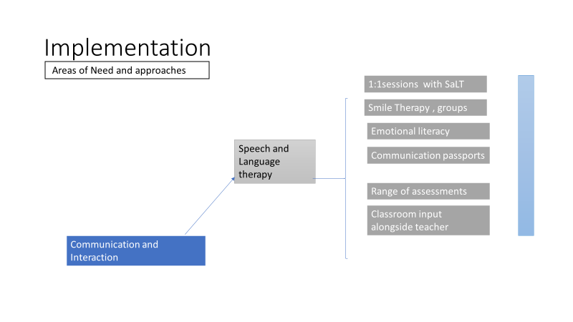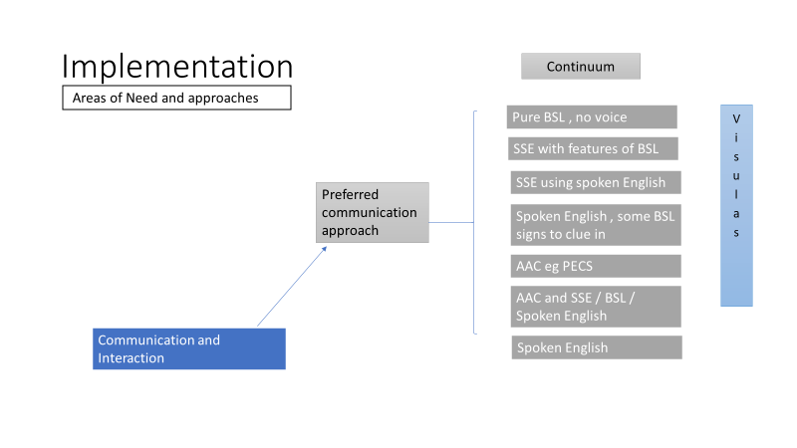

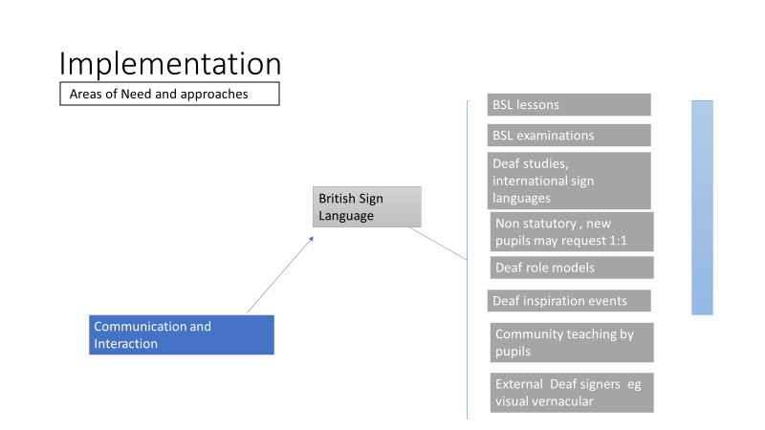

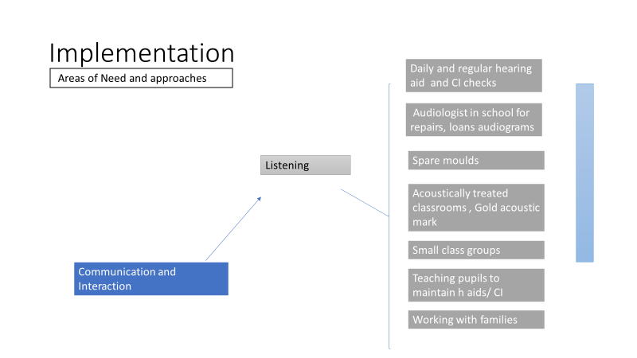

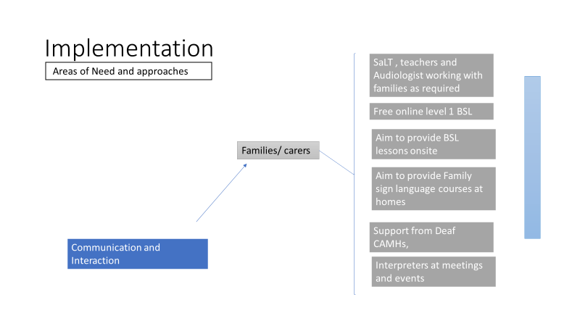

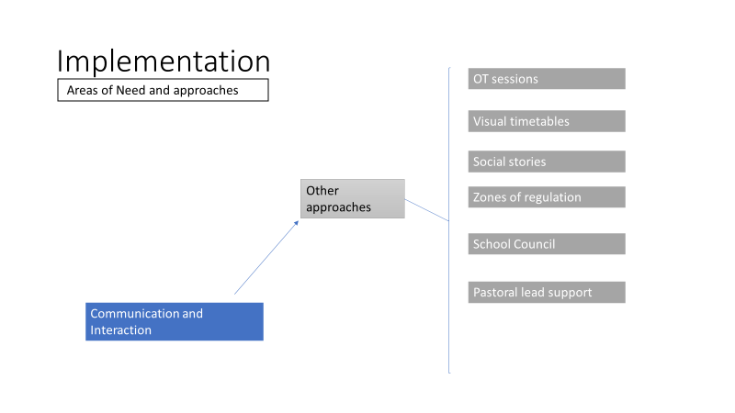

**Use of Interpreters for Deaf families**

In order to provide equality of access, DSD has a responsibility for providing an Interpreter for Deaf parents / carers for visits and activities where communication and the parents’ understanding of the school event is critical in supporting and promoting their child’s education and / or welfare, e.g.

* School meetings e.g. Parents’ Evenings, or similar consultation or information sharing meetings.
* Annual Review of Education, Health and Care Plan meetings.

**Principles for all Staff Members**

No member of the School Staff community should be disadvantaged, at any time, due to their choice of preferred language.

1. BSL and English hold the same status within the Doncaster School for the Deaf.

2. Staff are expected to use Sign Language (according to their ability), when communicating in communal areas, including the staff room, dining room, corridor, classes, playground etc. This is a matter of mutual respect and good manners.

3. In meetings, when deaf people are present there is the need to have full access through interpreters.

4. Communication needs vary from one person to another and from one situation to another and we need to retain flexibility interpreting these principles.

5. All staff are encouraged to work towards the next level of qualification in BSL.

(to Level 3 or 6)

**Annual Review Meetings**

All Annual Review meetings should be fully accessible to the pupil, deaf members of staff and deaf parents or other professionals who are present. Interpreters will be booked by the School Secretary.

**Office**

Admin staff are expected to acquire BSL skills to enable communication with deaf staff, pupils and other visitors to the School.

**Staffroom**

The staffroom is a communal area and as such needs to be fully accessible at all times in terms of communication. No member of staff should feel uncomfortable due to the fact that they are excluded from the general ‘chit-chat’ amongst colleagues.

# Monitoring and review

Copies of this policy and its related policies can be obtained the school office.

This policy is will be subject to review as a part of the school’s Self-Evaluation and Self-Review cycle.

Any changes made to this policy will be communicated to all members of staff.