School Uniform
Please make sure your child is correctly dressed
Primary
Sweatshirt | Blue(available from school) | 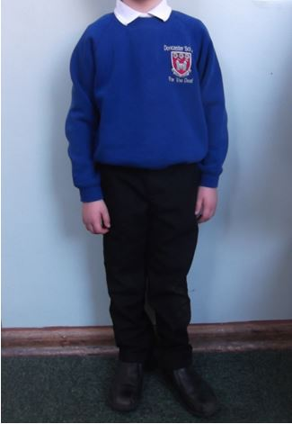
Trousers or Skirt | Black
Shoes or Trainers | Black
Polo Shirt or Shirt | White(without logos)
Summer Checked Dresses
Secondary
Knitted Jumper | Black (available from school) | 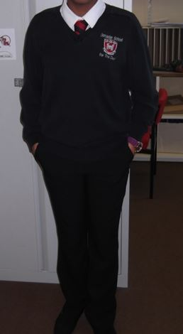
Trousers or skirt | Black or Grey
Shoes or Trainers | Black
Shirt | White
Tie | (available from school)
Primary and Secondary PE Kit
Polo shirt  shorts  Track-Suit  Trainers  Swimwear  Towel | Red  Blue or Black  Optional
Jewellery
Earrings (no hoops or dangling earrings)
No large rings on fingers
No facial piercings

